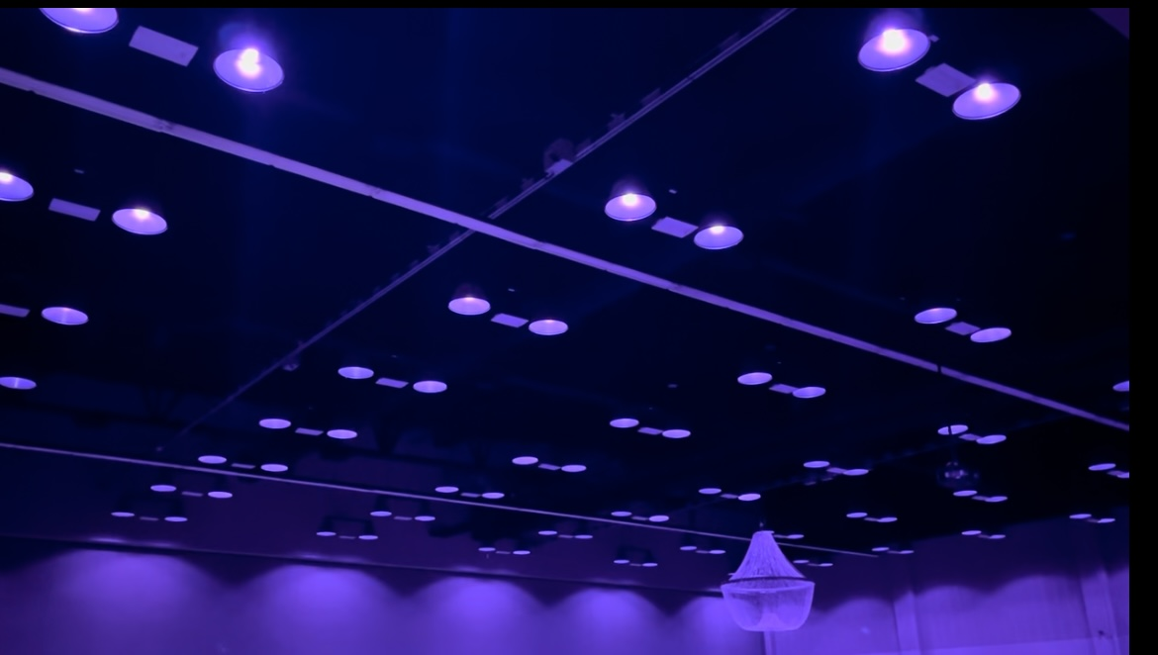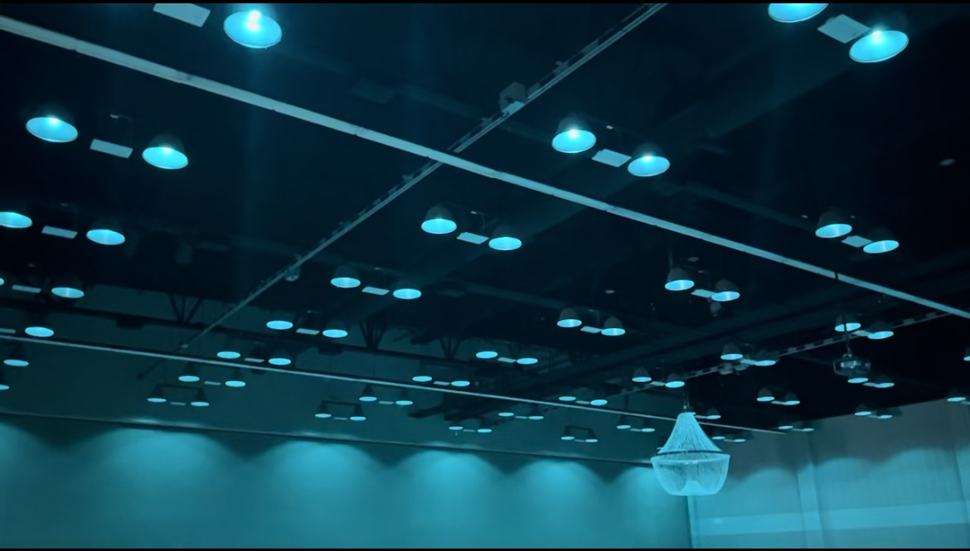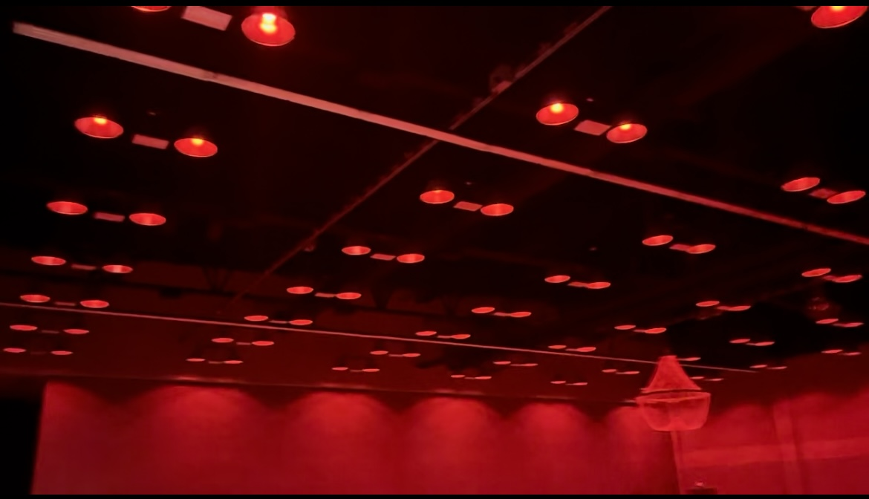  LED Custom Design Provided to The Center of Rural Development located in Somerset, KY.  Custom Lighting and Design for an event center  The Center for Rural Development is an event center that hosts a variety of events such as gala events, company retreats, vendors markets, and much more. They desired lighting that was updated, efficient, and easy to control. Above, you can see the lighting and how it can be changed at the click of a button from an easy-to-use phone/tablet application. For video demonstrations, please check out our website! | Who We Are  About Us  Jones Electrical Contractors has been serving The Commonwealth of Kentucky since 1970, providing a wide variety of electrical solutions.  In recent years, we have begun offering LED lighting design and installation in residential, commercial, and industrial settings.  We offer a FREE quote and cost-savings analysis to provide you with options and information on how you can benefit from LED lighting.  Our Services  - Commercial, Residential, Industrial Electrical Solutions  - LED Lighting and Custom Design  - FREE LED Cost Savings Analysis  - Generator Installation and Maintenance  - Excavation  - Marina Services  - Bucket Truck Services  - …. AND MORE!  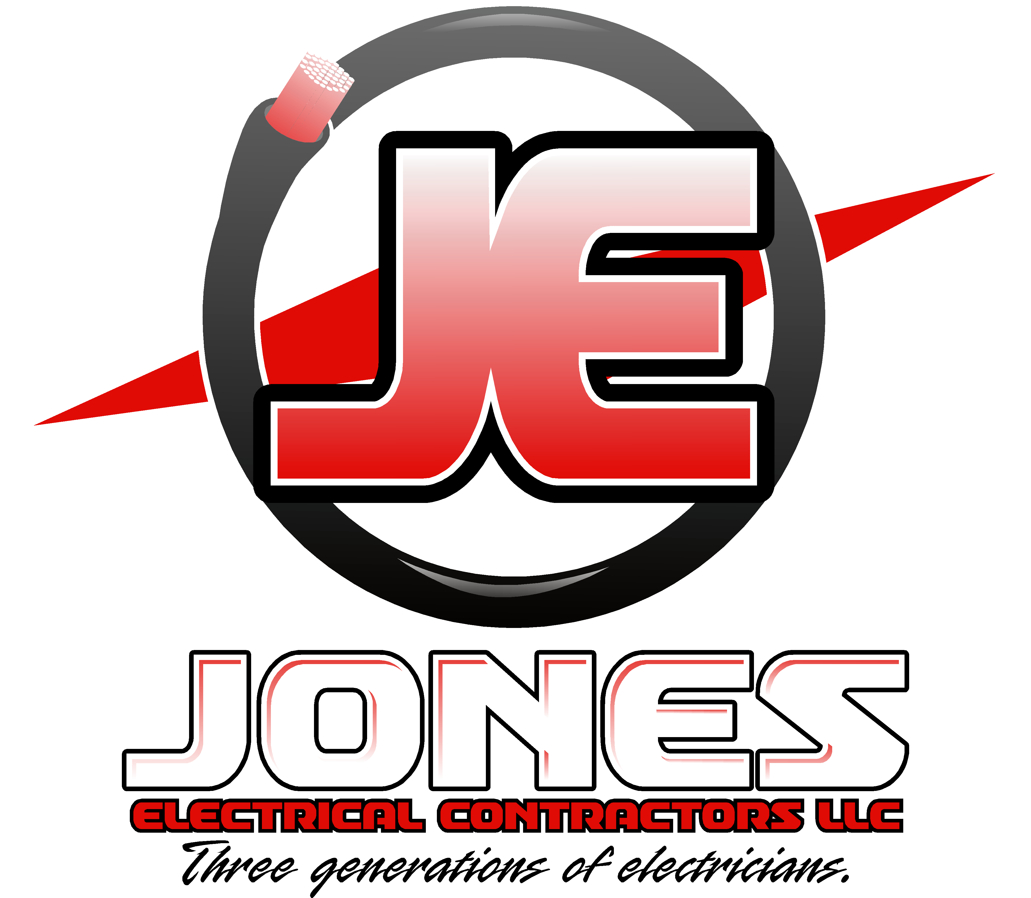 Jones Electrical Contractors Somerset, Kentucky | Why Chose LED?  - Saves you money!  - More efficient, longer lasting, and brighter!  - Less maintenance  - Increase the safety of your industrial or commercial building!  - Much More! Contact us today to see the upside of LED!  Contact Us Today!  Bryson Jones – Office/Sales Manager  (606) 305-1645  Jordan Jones – Owner/Operator  (606) 305-7990  Greg Jones – Owner/Operator  (606) 305-2866  JonesElectricInc@gmail.com  www.JonesElectricalContractorsLLC.com
Cost Savings for LED lighting vs other common options  How Does LED save money?  Efficiency  LED lighting is anywhere between 44% - 80% more efficient than fluorescent lighting, but what does this mean for you?  - 44-80% less energy consumption  - Longer lasting bulbs  - Lumens don’t depreciate  - Does not convert energy to heat  Your average fluorescent tube will pull about 376.88 kWh annually during 24/7 operation, while the same operation time in an LED bulb will pull roughly 140.16 kWh annually. That is an immediate 63% reduction in energy consumption if you switch to LED!  We have seen a jump in cost of electricity over the last couple of years. We have gone from an average of $.13 per kWh in 2013 to almost $.18 in 2024.  With kWh being the measurement of how much money you spend on electricity, the example above would equate to cutting the money you spend on keeping the lights on by over half! | “Lighting accounts for around 15% of an average home's electricity use, and the average household saves about $225 in energy costs per year by using LED lighting.” -Department of Energy  Potential safety for lighting design  The lighting design we offer not only has cost savings, but many other features!  Safety in the workplace is a growing concern over the last 20 years. This could be your opportunity to achieve cost savings and safety! The LED lighting, we provide can be programmed so that when an emergency occurs (fire, severe weather, etc.) the lights can change to a red color, indicating an emergency and notifying employees to proceed accordingly. This would be especially helpful in loud work environments! Check out our example on the previous page! | 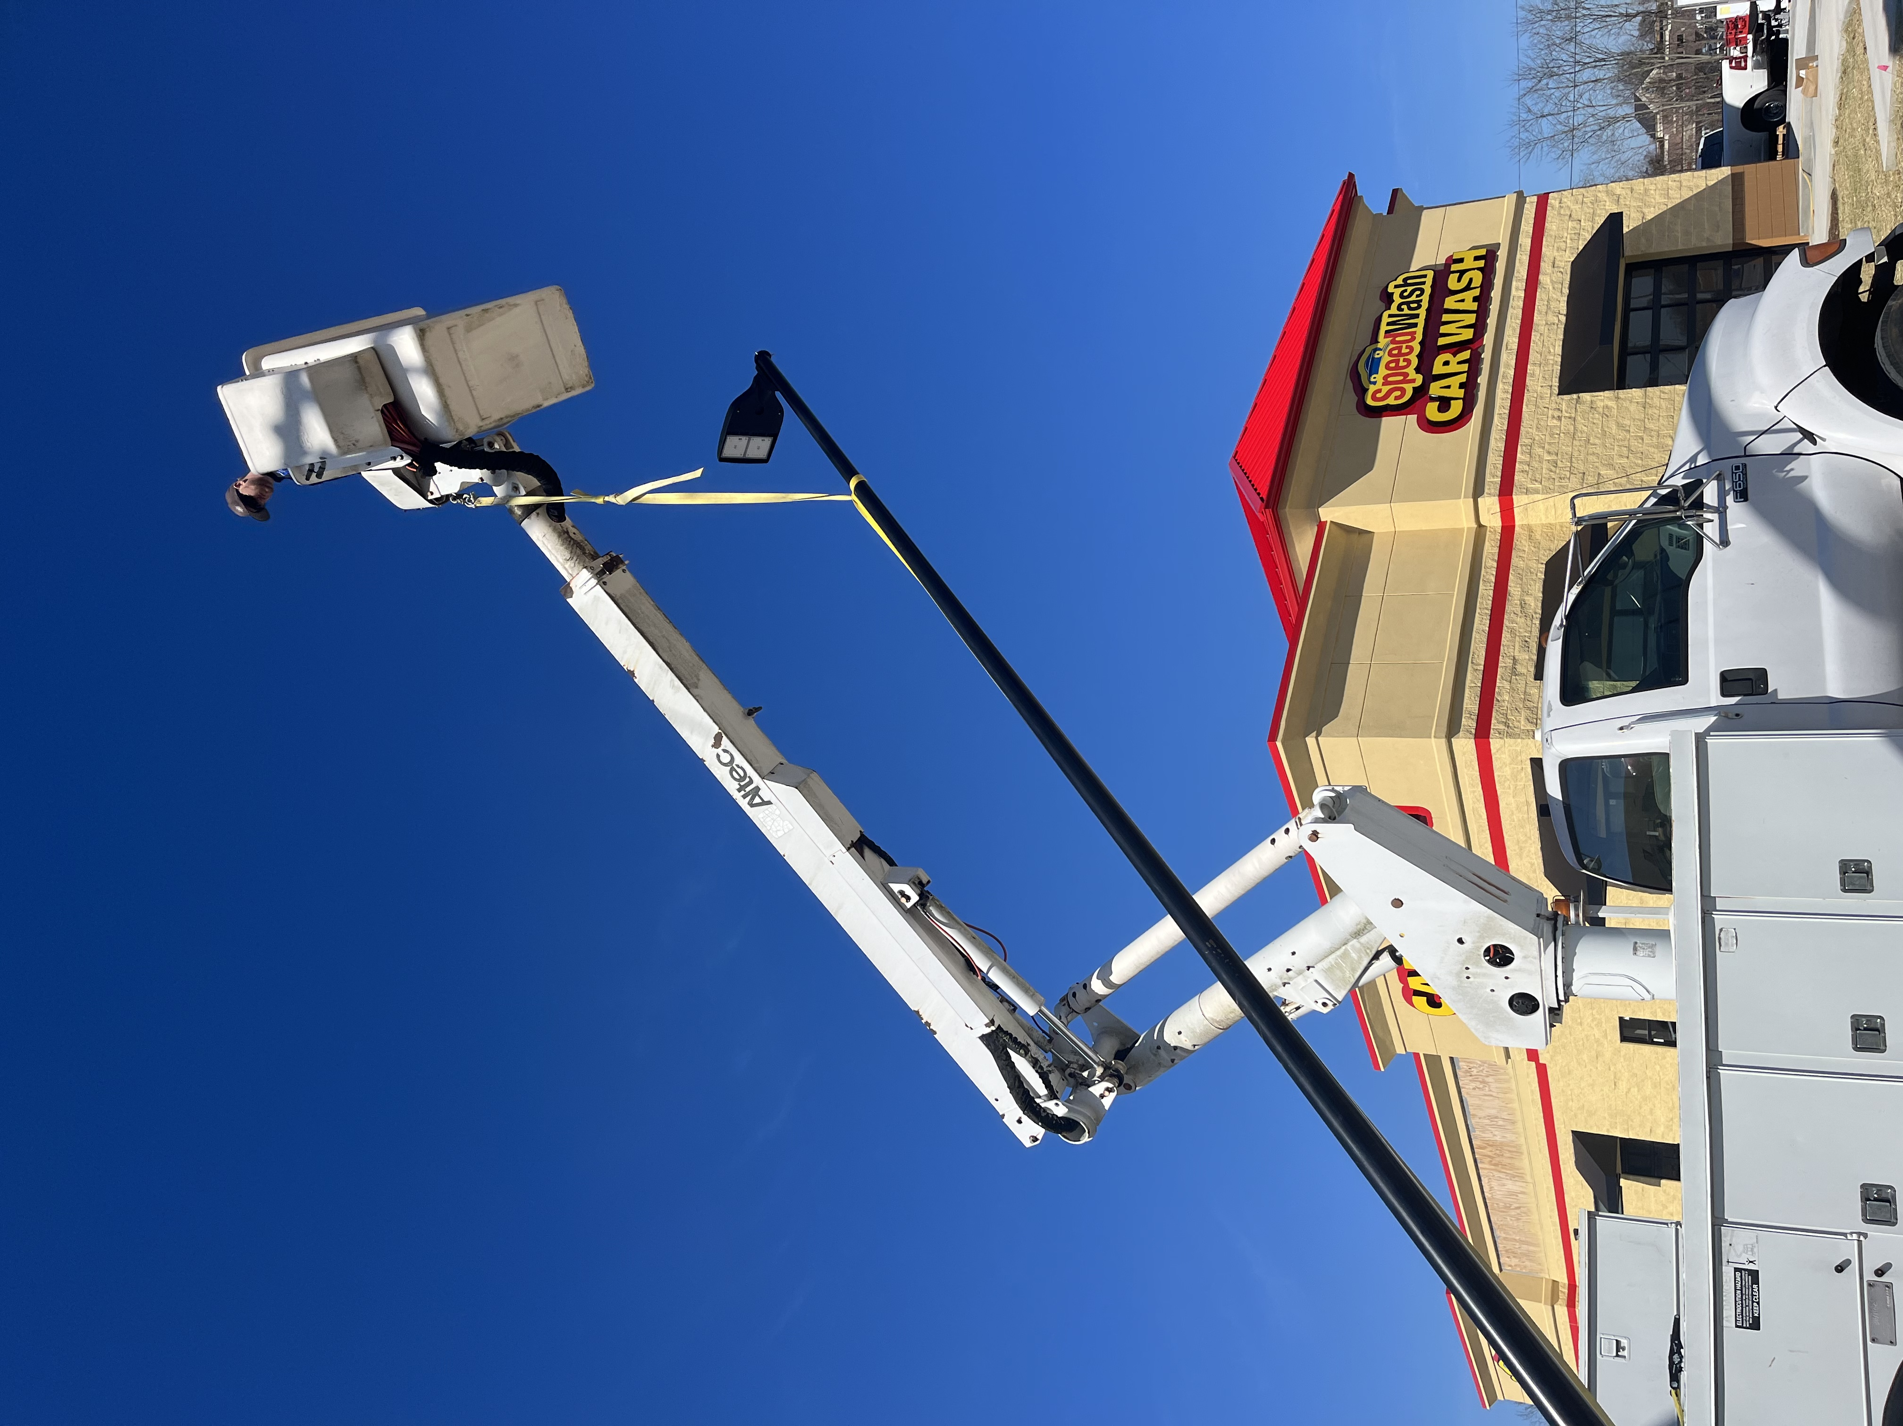  Pole, sign, and billboard lighting We not only offer indoor LED options, but outdoor as well! Billboards, pole lights, outdoor fixtures, ANYTHING you or your business needs, we offer!  Maintenance and Emergency  We offer a variety of services and can be readily available for maintenance and emergency needs! Contact us today to find out how we can benefit your company by being just a phone call away!  - Bucket Truck Service  - Lighting and Sign repair  - Exposed wiring repair  - ANY electrical need!

